Carbon Reduction Plan
Supplier name: Newcastle upon Tyne Hospitals NHS Foundation Trust
Publication date: 27 September 2024

Commitment to achieving Net Zero

Newcastle Hospitals is proud to be the first healthcare organisation in the world to declare a climate emergency and acknowledge the associated risk to patient health.
In 2020, we published a 5-year Climate Emergency Strategy which included the following vision and goals:

Our Vision
To be a global leader in sustainable healthcare delivery through collaboration and innovation, helping our patients and communities to thrive within the means of our planet

Our Goals
To achieve our vision we have set three long-term goals:
1. Zero Carbon Care
• By 2030 the emissions we control will be net zero – our ‘Newcastle Hospitals Carbon Footprint’
• By 2040 the emissions we can influence will be net zero – our ‘Newcastle Hospitals Carbon Footprint Plus’
2. Clean Air
• By 2030 our operational transport activities generate no harmful air pollution
• By 2040 our healthcare facilities are accessed by only zero emission travel
3. Zero Waste
• By 2030 we will reuse and repair everything that can be reused and repaired
• By 2040 we will produce no waste. We will manage resources within the circular economy, with items surplus to requirements becoming a resource in another part of the system

These carbon targets are ahead of the NHS targets as set out in the Health and Care Act 2022 and Delivering a Net Zero National Health Service report.

In 2021, we were the first healthcare organisation to become a signatory to the UNFCC Race to Zero.

Baseline Emissions Footprint
Baseline emissions are a record of the greenhouse gases that have been produced in the past and were produced prior to the introduction of any strategies to reduce emissions. Baseline emissions are the reference point against which emissions reduction can be measured.

Baseline Year: April 2019 – March 2020
Additional Details relating to the Baseline Emissions calculations.
We have adopted an operational control approach to setting the Carbon Footprint boundary and use the SmartCarbon Calculator to measure and report our carbon performance annually. The platform uses the UK Government Carbon Emission factors and supplementary healthcare specific factors, as well as a comprehensive supply chain hybrid approach. This methodology is in line with the NHS Net Zero Plan, The GHG Protocol Corporate Accounting and Reporting Standard, The Greenhouse Gas Protocol Corporate Value Chain (Scope 3) Accounting and Reporting Standard and technical guidance, as well as complying with the Streamlined Energy and Reporting Regulations (SECR).

Scope 1 and 2 emissions below include associated scope 3 emissions (WTT, T+D etc)

Please see our Annual Reports and SECR compliant reports for more details.

Baseline year emissions: April 2019 – March 2020
EMISSIONS | TOTAL (tCO₂e)
Scope 1 | 59,784
Scope 2 | 4,933
Scope 3  (Included Sources) | 191,674 (including water, waste, inhalers, business travel, patient transport service, staff commute, patient and visitor travel, purchased goods and services)
NHS Carbon Footprint (see Fig. 1 below) | 67,939
Total Emissions NHS Carbon Footprint Plus (see Fig. 1) | 256,391

Current Emissions Reporting
Reporting Year: April 2023 – March 2024
EMISSIONS | TOTAL (tCO₂e)
Scope 1 | 53,230
Scope 2 | 5,187
Scope 3  (Included Sources) | 328,904 (including water, waste, inhalers, business travel, patient transport service, staff commute, patient and visitor travel and purchased goods and services)
NHS Carbon Footprint (see Figure 1) | 61,459
Total Emissions NHS Carbon Footprint Plus (see Figure 1) | 387,321

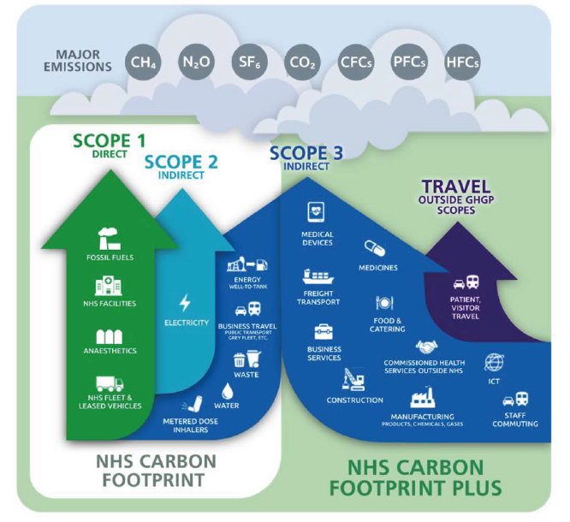
Figure 1. Greenhouse Gas Protocol scopes in the context of the NHS

Emissions reduction targets

In order to continue our progress to achieving Net Zero, we have adopted the following carbon reduction targets.

We project that carbon emissions from our NHS Carbon Footprint will decrease over the next five years to 6,793.9 tCO₂e by 2030. This is a reduction of 90%. This is dependent on us decommissioning our on-site fossil fuel combined heat and power energy centres and obtaining the external funding needed to replace these with renewable heat and power.

We have set a reduction target for our NHS Carbon Footprint Plus of 90% by 2040. This will be quantified in tCO₂e when we have calculated an accurate baseline.

Progress against our emissions reduction targets are publicly reported annually in our Shine Reports.

Carbon Reduction Projects

Completed Carbon Reduction Initiatives
The following environmental management measures and projects have been completed or implemented since the 2019 baseline for the emissions we control. The carbon emission reduction achieved by these schemes overall equates to 6,934 tCO₂e, a 10% reduction against the 2019 baseline and the measures will be in effect when performing the contract.
- The Tyndall Centre for Climate Change Research uses the principles of science and equity that are aligned with the commitments in the United Nations Paris Agreement to set budgets at national and sub-national levels, providing local authorities with recommendations that translate the ‘well below 2°C and pursuing 1.5°C’ global temperature target. We took that method and applied it at our organisational level for Newcastle Hospitals to calculate our own carbon budget – giving us the absolute total amount of carbon dioxide we can emit – 450,000 tCO₂e. To achieve this, we are required to reduce emissions by 18% per annum.
- We have a Sustainable Travel Plan and promote and incentivise the travel hierarchy to staff.
- We have commissioned an all-electric bus from local operator Go North East to run the staff hopper service. This equates to a carbon emission reduction of 178.02 tCO₂e (0.2%) against the 2019 baseline.

- We have decommissioned desflurane, an environmentally damaging volatile anaesthetic gas, trustwide and decommissioned the nitrous oxide manifold at the Freeman. We have implemented nitrous ‘cracking’ devices in our RVI maternity department. This equates to a carbon emission reduction of 2,632 tCO₂e (3%) against the 2019 baseline.

- We install energy efficient LED lighting as standard on refurbishments.
- We have installed solar panels on the roof of the multi-storey car park at Leazes Wing RVI.
- We received funding via PSDS Phase 3b to decarbonise Regent Point. The project is nearing completion and includes LED lights, heat pumps for the entire energy demand of the building, solar panels and BMS upgrades. Anticipated to save 120 tCO₂e per year.
- We utilise the Clean Air Hospital Framework (CAHF) as a tool to reduce local and global air pollution. Current self-assessed score against this framework is 30%.
- We are implementing our 30 year Biodiversity Management Plan to improve our biodiversity metric across our estate.
- We have established a dedicated Sustainable Supplier webpage, LinkedIn Group and email inbox to promote collaboration and knowledge share in the supplier community. We have over 850 supply chain companies actively engaged in our 5 step Net Zero Supplier Framework, collectively working towards our shared Net Zero target of 2040 for our scope 3 emissions (see note¹).
- We hold silver accreditation with Investors in the Environment
- We send zero waste to landfill (and have done since 2011)
- We use reusable sharps containers (and have done since 2004)

In the future we hope to implement further measures such as:

- Improvements to energy and water metering
- Further roll out of LED lighting and installation of solar panels
- Development of heat decarbonisation plans for community properties
- Withdrawal from Campus for Ageing and Vitality site
- Continue to apply for government grant funding (PSDS) to deliver our hospital decarbonisation programme
- Exploration of options to source heat from geothermal energy and city heat networks
- Decommissioning nitrous oxide manifold at the RVI (switching to a lean nitrous oxide supply where there is still a clinical need)
- Progress our 30 year Biodiversity Management Plan to improve our biodiversity metric across our estate
- Refresh and reissue our Sustainable Travel Plan
- Full electrification of our Trust fleet
- Improving access for staff owned electric bikes and pool electric bikes for community staff
- Improve infrastructure for active travel access to our sites
- Achieve a score of 50% on the Clean Air Hospital Framework as we progress towards our published target of excellent status by 2025 (over 70%)
- Increase confidence and accuracy in emissions associated with Scope 3 category 1, Purchased Goods and Services, by increasing the proportion of suppliers engaged in our 5-step framework and proportion of reported to estimated data in our hybrid calculation. Recalculate base year accordingly and track supplier progress to Net Zero on the SmartCarbon supplier dashboard.

Declaration and Sign Off
This Carbon Reduction Plan has been completed in accordance with PPN 06/21 and associated guidance and reporting standard for Carbon Reduction Plans.
Emissions have been reported and recorded in accordance with the published reporting standard for Carbon Reduction Plans and the GHG Reporting Protocol corporate standard and uses the appropriate Government emission conversion factors for greenhouse gas company reporting.
Scope 1 and Scope 2 emissions have been reported in accordance with SECR requirements, and the required subset of Scope 3 emissions. The full carbon footprint has been reported in accordance with the published reporting standard for Carbon Reduction Plans and the Corporate Value Chain (Scope 3) Standard.
This Carbon Reduction Plan has been reviewed and signed off by the board of directors.

Signed on behalf of the Supplier:
Sir James Mackey, Chief Executive
Date: 27.09.24


Sir Paul Ennals, Chairman
Date: 27.09.24

https://www.newcastle-hospitals.nhs.uk/wp-content/uploads/2024/06/Climate-strategy-2020-2025.pdf
https://racetozero.unfccc.int/system/race-to-zero/
https://www.smartcarboncalculator.com/
https://www.gov.uk/government/collections/government-conversion-factors-for-company-reporting
https://www.england.nhs.uk/greenernhs/a-net-zero-nhs/
https://ghgprotocol.org/corporate-standard
https://ghgprotocol.org/standards/scope-3-standard
https://ghgprotocol.org/scope-3-calculation-guidance-2
https://www.gov.uk/government/publications/environmental-reporting-guidelines-including-mandatory-greenhouse-gas-emissions-reporting-guidance
https://www.newcastle-hospitals.nhs.uk/about/sustainable-healthcare/shine-annual-reports/
https://www.england.nhs.uk/greenernhs/a-net-zero-nhs/
https://www.newcastle-hospitals.nhs.uk/about/sustainable-healthcare/shine-annual-reports/
https://www.newcastle-hospitals.nhs.uk/about/sustainable-healthcare/sustainable-suppliers/
https://ghgprotocol.org/corporate-standard
https://www.gov.uk/government/collections/government-conversion-factors-for-company-reporting
https://ghgprotocol.org/standards/scope-3-standard

