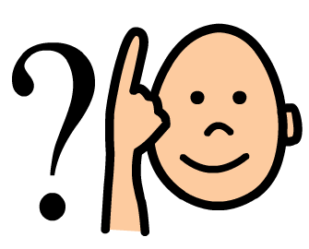
2 Word
Phrases

Speech and Language Therapy
0191 282 3085
Produced by: Paediatric Speech and Language Therapy, Newcastle upon Tyne
Advice Sheet

To help your child develop their understanding and use of language, it is important that you simplify your own language when talking to them.

Your child is able to understand and use a number of single words and some familiar phrases. The next step is to develop their understanding and use of two word phrases. For each section there is an activity to work on your child’s understanding of language and an activity to encourage their spoken language, to help them use more words.

Sometimes you may think your child is understanding everything you say but be aware that they will also be using other ‘clues’ such as your facial expression, gestures, tone of voice and the familiar routine to help them understand the instructions.

It is important to try and carry out some language activities with your child every day. It is only through regular practice that you will see progress in your child’s understanding and use of language.

Read through the games suggested here and pick out some to try with your child – you don’t have to do them in order

- Doing the games once or twice a day for five minutes is much better than half an hour a week.

- Stop before your child is bored - and make sure that you both find the games enjoyable.


Most of all have fun!
Produced by: Paediatric Speech and Language Therapy, Newcastle upon Tyne
Understanding

Language is often described in terms of key words (information carrying words). These are the essential words needed to convey the precise meaning of the sentence.

- Single word level e.g. “point to the cat”
(choice of cat and dog)

- 2 word level e.g. “point to the cat’s eyes”
(choice of cat and dog, eyes and ears)

- 3 word level e.g. “point to the big cat’s eyes”
(choice of big and little, cat and dog, eyes and ears)

Each activity has instructions which contain “key words”. These words are underlined and represent the number of items of vocabulary a child must understand in order to follow the instruction correctly.

For a “key word” to be valid, there must be a contrast item, e.g. the child is presented with dolly, teddy, plate and spoon. They are instructed to “Give teddy the plate”. The child needs to understand the 2 words underlined, i.e. that it’s a teddy not a dolly, and a plate not a spoon.
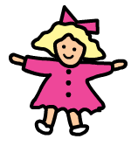
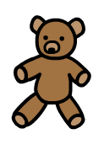



BUT if the child was presented with a teddy, plate and spoon and instructed to “Give teddy the plate”, they only need to understand “plate”, as there is no other toy apart from teddy to give the plate to.
Produced by: Paediatric Speech and Language Therapy, Newcastle upon Tyne
Expression

You may also want to develop your child’s spoken language. This can be done by taking it in turns to give instructions. Initially your child may need a lot of prompting, and explanation that they are now the ‘teacher’ and must tell you what to do.

If they find it difficult, you could begin by splitting it up into easier stages, e.g.

“Who shall we have - dolly or teddy?”
“Dolly”

“What’s dolly going to do?”
“Jump”

“So I’ve got to ‘make dolly jump’. Can you tell me now?”
“Make dolly jump”

General points

- Demonstrate each activity first to your child

- Don’t split up the command as this reduces the level of understanding

Make sure that you don’t always ask your child to do the obvious thing, e.g. the milk doesn’t necessarily need to go in the fridge.
Produced by: Paediatric Speech and Language Therapy, Newcastle upon Tyne
Understanding
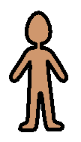
Body Parts

Equipment
- Picture of boy and girl
- Crayon or pen

Instructions
Cut the pictures up into pieces;
e.g. arms, legs, head, feet, hands etc.

Ask your child to put them together again by giving them one instruction at a time;
e.g. “Find the girl’s leg”
“Find the boy’s head”

Alternatively, give your child a crayon or pen and ask them to colour in different body parts;
e.g. “Colour the boy’s hair”

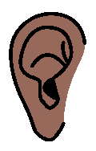
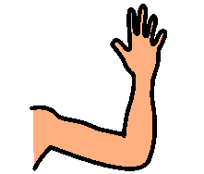
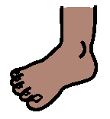
Produced by: Paediatric Speech and Language Therapy, Newcastle upon Tyne
Expression
Body Parts

Equipment
- Picture of boy
- Picture of girl

Instructions
Cut the pictures up into pieces;
e.g. arms, legs, head, feet, hands etc.

Encourage your child to describe the pieces;
e.g. “Boy’s head”
“Girl’s arm”

You can also get your child to give the instructions and tell you which piece to find. If they are reluctant to name the pictures try prompting them by saying “it’s a…” or by naming it incorrectly and encouraging them to correct you.

Alternatively, give your child a crayon or pen. Ask them to tell you what body part they are colouring in.
e.g. “Girl’s foot”

Produced by: Paediatric Speech and Language Therapy, Newcastle upon Tyne
Understanding
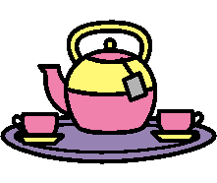
Tea Party

Equipment
- Two toys e.g. teddy and dolly
- Toy food or pictures of food

Instructions
Pretend it is tea time or that you are having a picnic.
Put teddy and dolly out in front of your child and tell them that they are hungry and would like something to eat.
Put out some food, naming it for your child;
e.g. “Apple”
“Banana”

Once you have put all the items out, ask your child to feed the toys certain items;
e.g. “Give dolly some apple”
“Give teddy some banana”

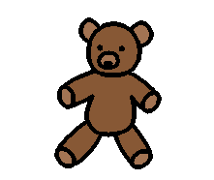
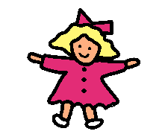
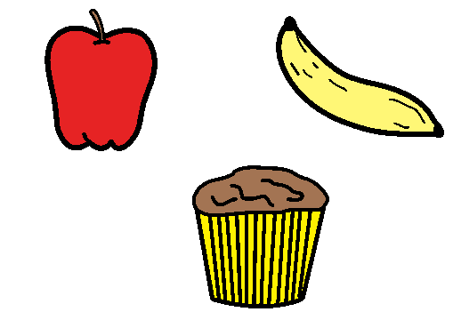
Produced by: Paediatric Speech and Language Therapy, Newcastle upon Tyne
Expression
Tea Party

Equipment
- Two toys e.g. teddy and dolly
- Toy food or pictures of food

Instructions
Pretend it is tea time or that you are having a picnic.
Put teddy and dolly out in front of your child.
As you put the food out, encourage your child to name the items;
e.g. “Banana”
“Orange”

Once you have put all the items out, ask your child to give the instructions and tell you what to feed teddy and dolly;
e.g. “Give dolly orange”
“Give teddy’s banana”

Produced by: Paediatric Speech and Language Therapy, Newcastle upon Tyne
Understanding
Hiding Game

Equipment
- A selection of 4 everyday objects
- 2 places to hide objects e.g. a box and a cupboard

Instructions
Tell your child that you want them to hide some objects, show them where they will be putting them;
e.g. in the box or in the cupboard.

Now ask your child to hide one of the objects;
e.g. “Hide the spoon in the cupboard”
“Hide the ball in the box”

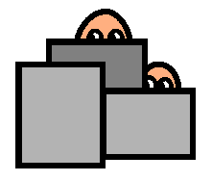
Produced by: Paediatric Speech and Language Therapy, Newcastle upon Tyne
Expression
Hiding Game

Equipment
- A selection of 4 everyday objects
- 2 places to hide objects e.g. a box and a cupboard

Instructions
Show your child two places that you can hide objects in;
e.g. in the box or in the cupboard.

Now ask your child to tell you where to hide one of the objects;
e.g. “Cup in the cupboard”
“Spoon in the box”

Produced by: Paediatric Speech and Language Therapy, Newcastle upon Tyne
Understanding
Action Game

Equipment
- Two toys e.g. teddy and dolly

Instructions
Show your child that the toys can perform various actions;
e.g. sit, jump, walk etc.

Give your child the other toy and encourage them to make their toy do the same actions as you.

Now place both toys in front of your child and ask them to;
“Make teddy jump”
“Make dolly sit”

Once your child is confident with this, you can start to introduce more actions;
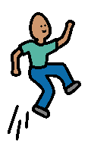
e.g. Run
Walk
Crawl
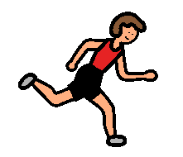
Dance
Sleep
Wave
Kick
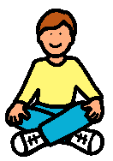
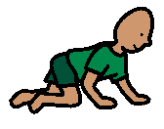
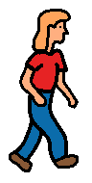
Produced by: Paediatric Speech and Language Therapy, Newcastle upon Tyne
Expression
Action Game

Equipment
- Two toys e.g. teddy and dolly

Instructions
Choose a toy and show your child that it can perform various actions;
e.g. sit, jump, walk etc.

Encourage your child to describe what the toy is doing;
e.g. “Teddy’s jumping”
“Teddy’s walking”
“Teddy’s standing”

Once your child is confident with this, encourage them to tell you what to make teddy do.

You can then repeat this activity using two toys, getting your child to tell you which toy to do the action with;
e.g. “Teddy jump”
“Dolly walk”

Produced by: Paediatric Speech and Language Therapy, Newcastle upon Tyne
Understanding
Washing Game

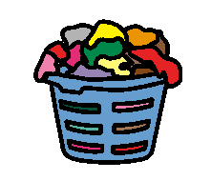
Equipment
- Items of clothing if possible
OR
- Pictures of big and little clothes

Instructions
Tell your child that you are going to be sorting some washing.

If you have items of clothing you can ask your child to give you specific people’s clothes;
e.g. “Give me daddy’s socks”
“Give me baby’s jumper”

Otherwise ask your child to find an item from the pictures. Make sure you put both big and little items out;
e.g. “Find the big hat”
“Find the small trousers”
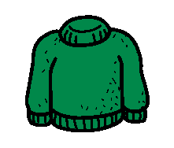

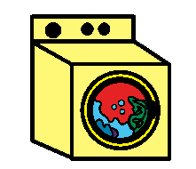
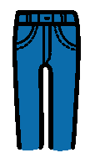

Produced by: Paediatric Speech and Language Therapy, Newcastle upon Tyne
Expression
Washing Game

Equipment
- Items or pictures of clothing
- Washing machine (toy or picture)

Instructions
Tell your child that you are going to be sorting some washing.

Ask your child to tell you what to put in the wash;
e.g. “Daddy’s socks”, “Baby’s jumper”
OR
“Little trousers”, “Big coat”

Produced by: Paediatric Speech and Language Therapy, Newcastle upon Tyne
Understanding
Tidying the Table

Equipment
- Cups, plates, cutlery etc.
- Two toys e.g. teddy and dolly

Instructions
If possible let your child help clear the table.
Alternatively, sit two toys at a table with cups and plates etc. in front of them.

Ask your child to bring you specific items;
e.g. “Bring me daddy’s cup”, “Bring me mummy’s spoon”
OR
“Bring me teddy’s plate”, “Bring me dolly’s knife”


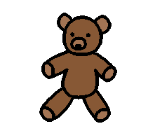

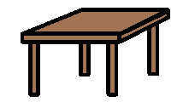

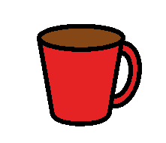
Produced by: Paediatric Speech and Language Therapy, Newcastle upon Tyne
Expression
Tidying the Table

Equipment
- Cups, plates, cutlery etc.
- Two toys e.g. teddy and dolly

Instructions
If possible let your child help clear the table.
Alternatively, sit two toys at a table with cups and plates etc. in front of them.

Ask your child to tell you what to get;
e.g. “Daddy’s cup”, “Mummy’s spoon”
OR
“Teddy’s plate”, “Dolly’s knife”

Alternatively, when your child brings you an item, ask them “what have you got?” encouraging them to respond with two words;
e.g. “Daddy’s spoon”
“Teddy’s cup”

Produced by: Paediatric Speech and Language Therapy, Newcastle upon Tyne
Understanding
Cleaning Game
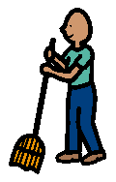
Equipment
- Items to clean
- Objects to clean with e.g. brush, towel

Instructions
Let your child help clean furniture or household items.

Tell your child what they have to do;
e.g. “Brush the floor”
“Wash the plate”
“Dry the spoon”


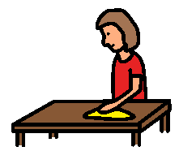
Produced by: Paediatric Speech and Language Therapy, Newcastle upon Tyne
Expression
Cleaning Game
Equipment
- Items to clean
- Objects to clean with e.g. brush, towel

Instructions
Let your child help clean furniture or household items.

Ask your child to tell you what to do;
e.g. “Dry the cup”
“Wash the knife”

Alternatively, when your child brings you an item, ask them to tell you what they are doing;
e.g. “Brushing the floor”
“Drying the plate”
Produced by: Paediatric Speech and Language Therapy, Newcastle upon Tyne
Understanding
Bath time

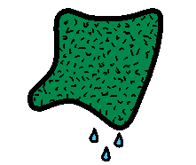
Equipment
- Two toys e.g. teddy and dolly
- Cloth for washing toys

Instructions
Pretend it is bath time – you could use a toy bath to support this.
Put teddy and dolly out in front of your child.

Ask your child to wash parts of the toys;
e.g. “Wash dolly’s hair”
“Wash teddy’s arm”

You could also repeat this activity for drying;
e.g. “Dry teddy’s leg”
“Dry dolly’s face”
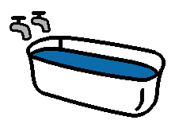
Produced by: Paediatric Speech and Language Therapy, Newcastle upon Tyne
Expression
Bath time

Equipment
- Two toys e.g. teddy and dolly
- Cloth for washing toys

Instructions
Pretend it is bath time – you could use a toy bath to support this.
Put teddy and dolly out in front of your child.
Ask your child to wash parts of the toys

Encourage your child to tell you what they are washing;
e.g. “Dolly’s face”
“Teddy’s leg”

Alternatively, encourage them to tell you what to wash.
e.g. “Dolly’s tummy”

You could also repeat this activity for drying.
e.g. “Dry teddy’s leg”
“Dry dolly’s face”
Produced by: Paediatric Speech and Language Therapy, Newcastle upon Tyne
Understanding
Clothes line Game

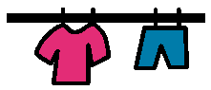
Equipment
- Two toys e.g. teddy and dolly
- Clothes pictures – 2 copies
- Clothes line (toy or picture)

Instructions
Cut out the clothes.
Put teddy and dolly out in front of your child.
Give teddy and dolly some clothes to show them what you want them to do. Remember to say whose clothes they are;
e.g. “Teddy’s jumper”, “Dolly’s jumper”
“Teddy’s hat”, “Dolly’s hat”

Then ask your child to give an item to teddy or dolly;
e.g. “Give the jumper to teddy”
“Give the hat to dolly”

Once you have given teddy and dolly their clothes you could ask your child to hang the clothes up on the clothes line;
e.g. “Hang up dolly’s hat”
“Hang up teddy’s socks”

Produced by: Paediatric Speech and Language Therapy, Newcastle upon Tyne
Expression
Clothes line Game

Equipment
- Two toys e.g. teddy and dolly
- Clothes pictures – 2 copies
- Crayons
- Clothes line (toy or picture)

Instructions
Cut out the clothes.
Ask your child to colour in the clothes, and say whose they are;
e.g. “Teddy’s jumper”
“Dolly’s hat”

Ask your child to tell you what item to give teddy or dolly;
e.g. “Jumper to teddy”
“Hat to dolly”

You could also do this activity using a clothes line.
Ask your child to tell you what items to hang up or alternatively ask your chid to tell you what items they have hung up;
e.g. “Dolly’s hat”
“Teddy’s socks”

Produced by: Paediatric Speech and Language Therapy, Newcastle upon Tyne
Understanding
Animal Parts

Equipment
- Pictures of dog, cat and rabbit
- Crayon or pen

Instructions
Cut the pictures up into pieces;
e.g. tail, ears, legs etc.

Ask your child to put them together again;
e.g. “Find the dog’s tail”
“Find the rabbit’s leg”

Alternatively, give your child a crayon or pen and ask them to colour in different animal parts;
e.g. “Colour the dog’s ears”
“Colour the cat’s tail”

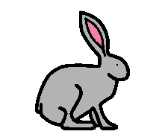
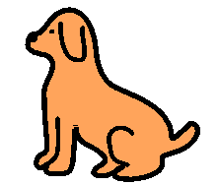
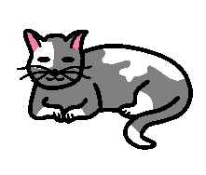
Produced by: Paediatric Speech and Language Therapy, Newcastle upon Tyne
Expression
Animal Parts

Equipment
- Pictures of dog, cat and rabbit
- Crayon or pen

Instructions
Cut the pictures up into pieces;
e.g. tail, ears, legs etc.

Encourage your child to describe the pieces;
e.g. “Dog’s leg”
“Rabbit’s ears”

You can also get your child to tell you which piece to find.

Alternatively, give your child a crayon or pen. Ask them to tell you what part they are colouring in.
e.g. “Dog’s ears”

You can also get your child to tell you which piece to colour.
e.g. “Cat’s tail”
Produced by: Paediatric Speech and Language Therapy, Newcastle upon Tyne
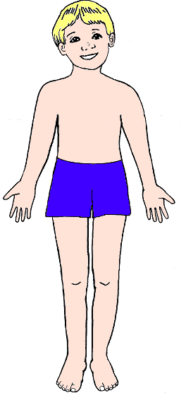
Body Parts Pictures
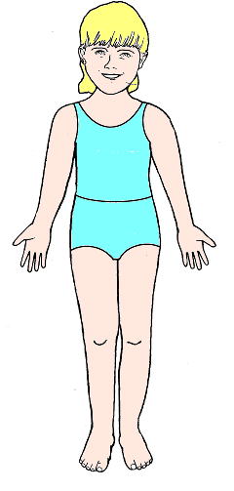
Body Parts Pictures
Tea Party Pictures

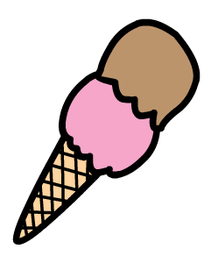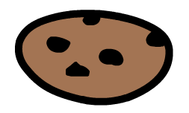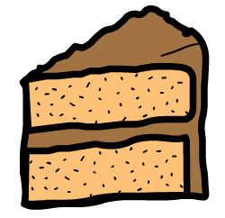
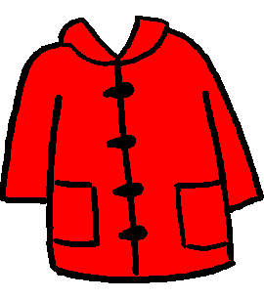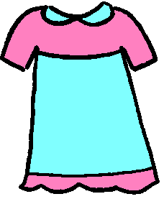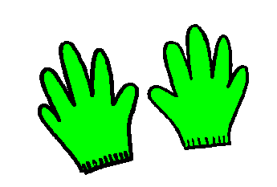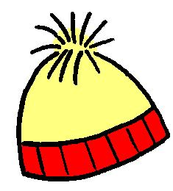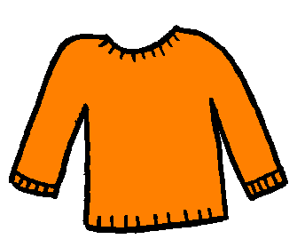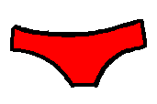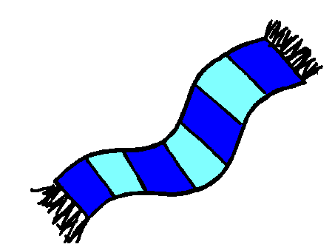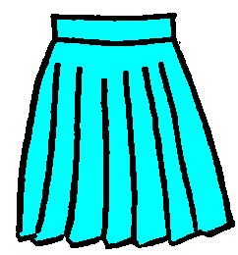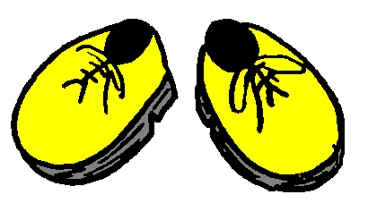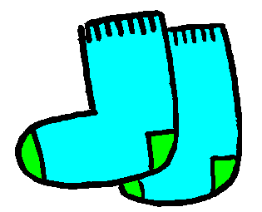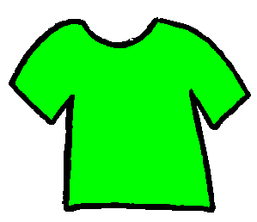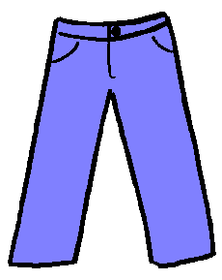
Washing Game Pictures

Washing Game Pictures
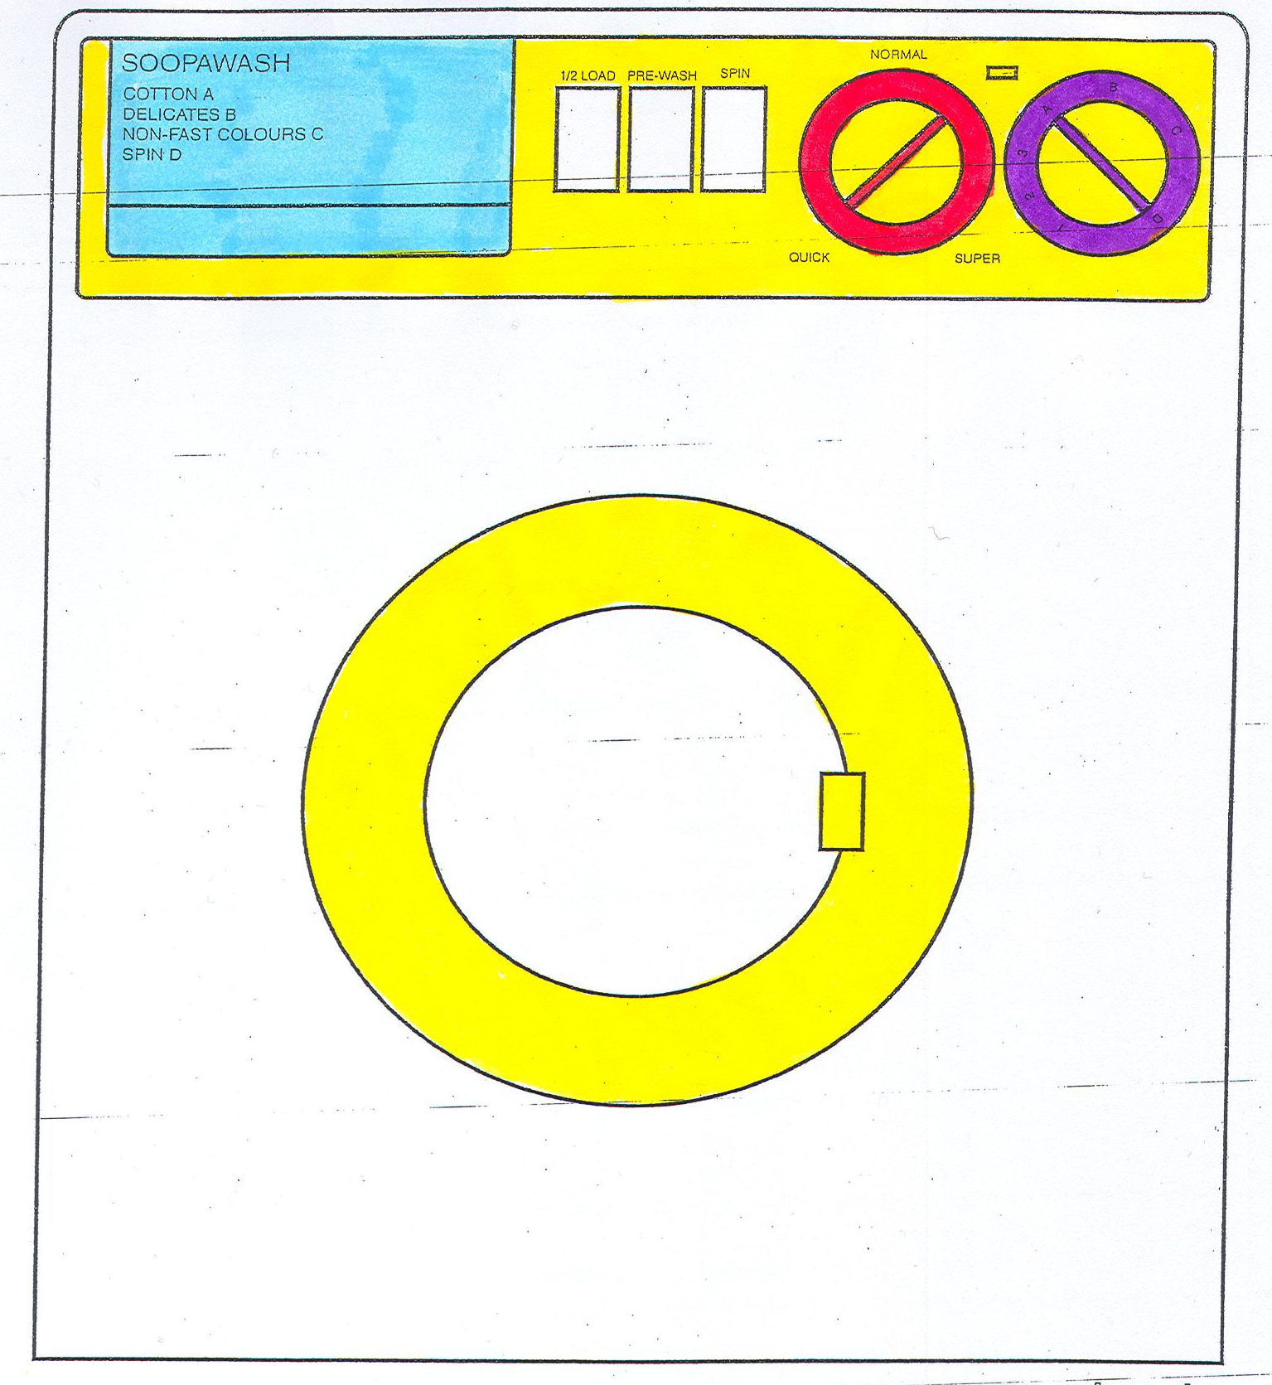
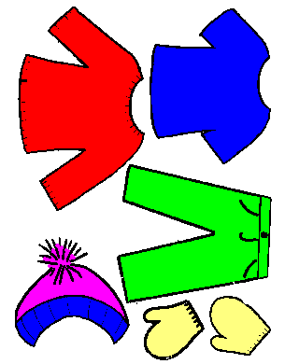
Clothes Line Game Pictures

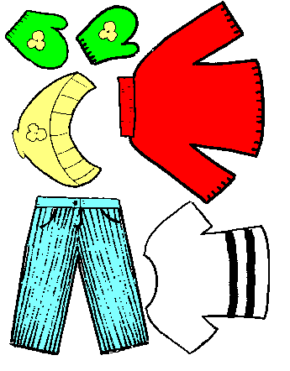
Clothes Line Game Pictures

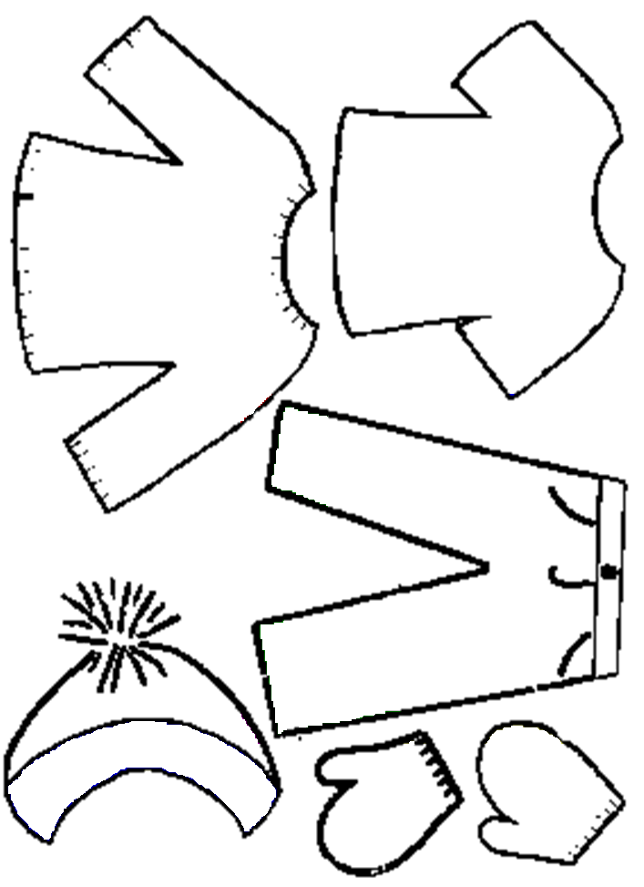
Clothes Line Game Pictures – to colour

Clothes Line Game Pictures – to colour

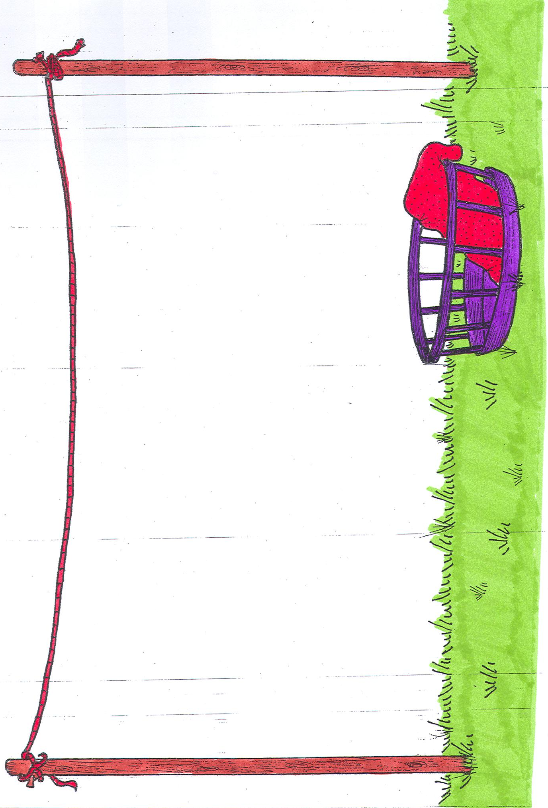
Clothes Line Game Pictures
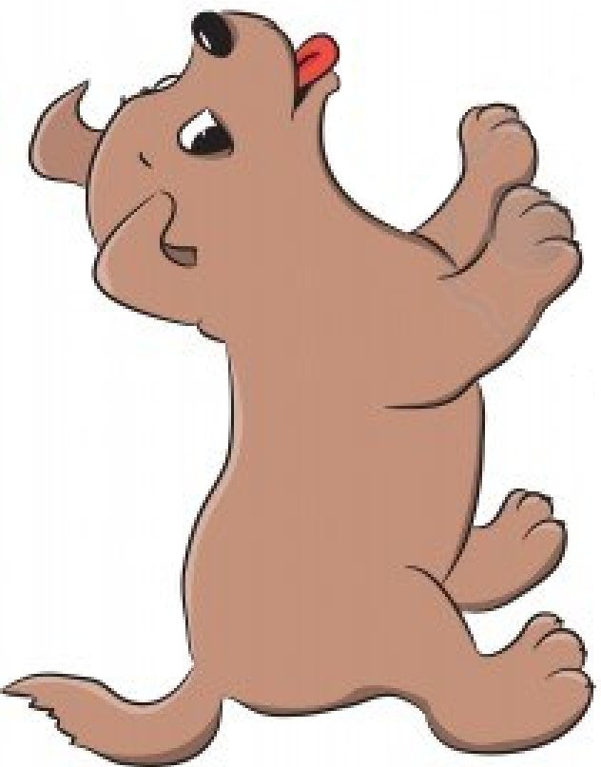
Animal Parts Pictures
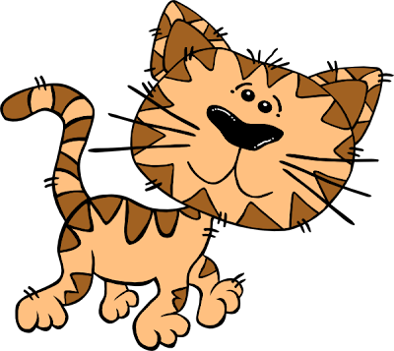
Animal Parts Pictures
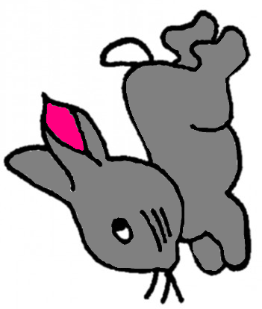
Animal Parts Pictures
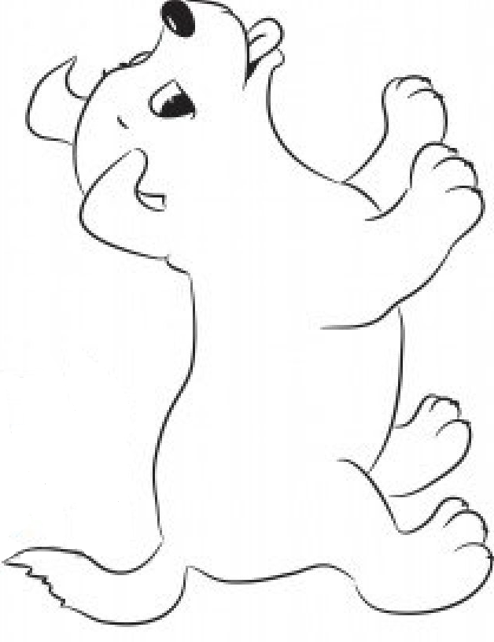
Animal Parts Pictures – to colour
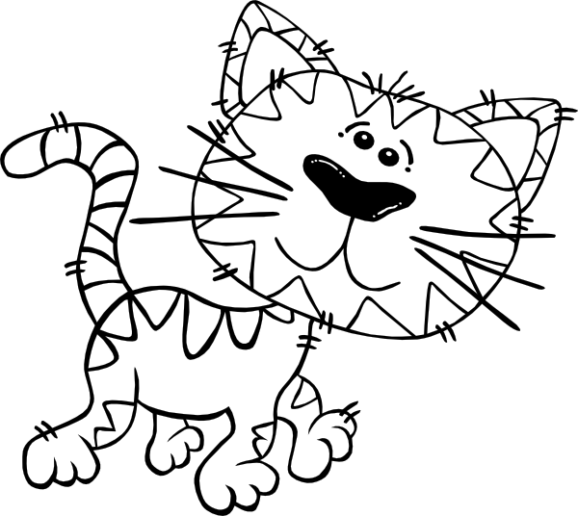
Animal Parts Pictures – to colour
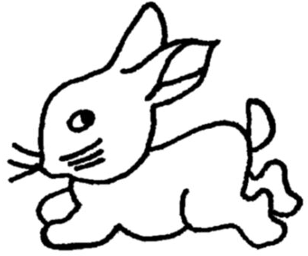
Animal Parts Pictures – to colour

