Understanding Words
Activities to encourage your child to listen and understand instructions with 2 parts

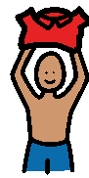
Getting dressed
When your child is getting dressed lay out the clothes they are going to wear on the bed. Ask them to select 2 items at a time e.g. ‘t-shirt and shorts’.
Remember don’t give your child clues, if you hold up a t-shirt and say to your child ‘put the t-shirt on’ they do not need to
understand any of the words because they can see what they need to do.

Shopping game
Lay out 6 pretend food objects and ask your child to find 2 items at a time or put them in a basket e.g. ‘find me banana
and orange

Tidy up time
During tidy up time ask your child to tidy away 2 items at a time e.g. ‘ball and train’

Farm yard
Use animal figures and a farm scene. Ask your child to put 2 animals in the farm at a time or put them in different places in the farm,
e.g. ‘put pig in the mud’ ‘ put sheep on the grass’


Games with teddy and dolly
Use a teddy and a doll. Give instructions such as: ‘make teddy sit’, ‘make doll sleep’, ‘make teddy jump’, ‘make doll walk’

Teddy and dolly’s tea party
Place a teddy and dolly in front of your child with a selection of objects then give them instructions e.g. give spoon to dolly
give a cup to teddy
Games with teddy and dolly
Use a teddy and a doll. Give instructions such as: ‘make teddy sit’, ‘make doll sleep’, ‘make teddy jump’, ‘make doll walk’

Teddy and dolly’s tea party
Place a teddy and dolly in front of your child with a selection of objects then give them instructions e.g. give spoon to dolly
give a cup to teddy
Games with teddy and dolly
Use a teddy and a doll. Give instructions such as: ‘make teddy sit’, ‘make doll sleep’, ‘make teddy jump’, ‘make doll walk’

Teddy and dolly’s tea party
Place a teddy and dolly in front of your child with a selection of objects then give them instructions e.g. give spoon to dolly
give a cup to teddy
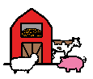

Pass the ball
Use a ball, car, teddy, and dolly. Ask your child to pass the ball or car to teddy or dolly. For example:
‘pass the ball to teddy’, ‘pass the car to dolly
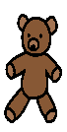
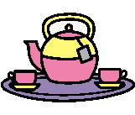
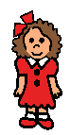

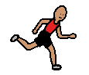
Action games
Play games with actions
e.g. tell your child to: ‘run to the door’, ‘hop to the tv’, ‘crawl to the chair,’ ‘walk to the window’

